CHAMBER SEARCH ENGINE
Quick Reference TRAINING GUIDE AND CHECK LIST
CHAMBER SEARCH ENGINE MEMBER MODULES
(quick overview of available services for the Mark LeBlanc Edition)
Included Member Modules Designed to Power the Chamber Search Engine within your Community | It all starts with receiving an email from your Chamber of Commerce. This email will invite you into a powerful local marketing and advertising program that powers the Chamber Search Engine. This search engine becomes the most powerful local search tool for our community. In order for your business to be part of this search solution, you MUST OPTIMIZE (Complete) the steps below. Since search engines rely on information to produce the result, the more you have about your business the better the search results about your business will be.  User Name and Password: To login to the Chamber Search Engine simply go to the Chamber Website and locate the “Member Login” link. After you enter the Chamber Search Engine program for the first time, you’ll have the option to change both the user name and password so it’s easy for you to remember in the future. If it’s the first time you log in please look for the flashing “Click Here” button.  Primary Photo: The primary photo you will be asked to provide will show on your new Chamber Search Engine website.  About Us: It is very important to add as much information about your company in the box as it helps the search engine determine if you provide the services the visitor is looking for.  Business Hours: The search result will deliver people to your online presentation. This presentation includes your business contact information and hours of operation. Mobile phone users will also see a “Business Hours” link to see what time your business is open to serve them.  Service Bullets: It is very important to add as much information about your company in the boxes as it helps the search engine determine if you provide the products or services the visitor is looking for.  Fundraisers You Support: This allows you to share with the public online about the fundraisers within the community that you support. It’s a great PR opportunity.  Mobile Phone Site Domain: Mobile phone usage is growing much faster than computer search services. For this reason the Chamber Search Engine promotes your business through a separate website designed for mobile phone visitors. You will be asked to choose a domain for this site too.  Create Defining Statement: People will say “I don’t want to see your website I just want to get to the information I am looking for.” The defining statement is the first step in helping you create the presentation needed to convey the information people are looking for.  Create Your Keywords: Within the narrative about what you provide as a business and organization might be valuable for people to read, but they typically use a search engine to look for specific words or phrases. Use this module to create a huge list of words that will help people find you based on exactly what they are looking for.  Define Your Target Market: People using the search engine are looking for a specific solution. By adding information about your target market people are able to easily find you based on the industry they are in.  Create Your Mission Statement: Why should I do business with you? The mission statement helps you quickly and concisely convey to your viewers why they should trust you to deliver what they are looking for.  Download Small Business Success Book: Mark LeBlanc is the author of a book called “Growing Your Business” that’s designed to tie into the Chamber Search Engine technology. Download this book at no cost from within the Chamber system.  Edit Site: This link will allow you to go through the initial setup of your Chamber Search Engine program. It’s a great way to be sure that your site is up-to-date and easily make changes.  Primary Photo: It’s like the interview for a new job… first 30 seconds the interviewer typically knows if they will hire you or not. When a person gets the result from the search engine the first thing they will see in many cases is this photo. Be sure it tells a story about your business or maybe even a photo of your staff.  Company Logo: Upload your logo and if you don’t have a logo that can be used for your online advertising contact us at www.FreeMembersSupport.com and we’ll create one for you at NO charge.  Business Tour Photos: Along with your primary photo mentioned above, a photo tour / presentation is created with up to 10 images. Photos of your business, staff or even customers waving will speak volumes about you. It’s simple to do and provides so much goodwill that it’s something you really should do.  News Articles: Remember that this site will be accessed many times and once people find you through the Chamber Search Engine don’t disappoint them. Add news stories when you expand or add new product or services lines, get references from customers and more.  Links to Social Networks: The Chamber provides members with an exceptional way to promote your business. Now as people find you through the search engine and via the Chamber member directory, you can easily suggest that they ALSO view all of your other locations on the web. One site with a lot of valuable information.  Coupon Creator / Special Offers: When the economy is tough people depend on many things to keep their costs down. Coupons are one of many ways businesses promote their business and the Chamber makes this easy for you to do. Do not confuse this service with the Community on Display or My Ad Cloud program as the coupon creator is designed to work directly with the Chamber Search Engine program.  Members You Do Business With: Search results will deliver people to many businesses within the community. If others already work with your company, and they state this within this program then that becomes a 3rd party reference shown on the directory and your search engine website. This helps promote your business so be sure to promote others that you do business with you by using this service. A 3rd party reference is always the most powerful advertising you can ask for.  Mobile Phone Site: The mobile phone site is generated and updated automatically whenever you make changes to your Chamber Search Engine program. Your Chamber promotes a mobile version of their main website that includes you and becomes a wonderful local resource and business directory tool on any Internet cell phone.  Catalog Shopping Link: If you choose to use the “My Ad Cloud” services (sometimes also included in your membership) this link will be automatically activated for you. If you are not using the “My Ad Cloud” service, but already have an online store or eBay account you can enter the link here and people viewing your search result will notice that you have an online store.  Lodging Reservations Link: If you are using the “My Ad Cloud” services you can setup a free reservation request system, but if you already have this available somewhere else online then you will want to place the link to that service here. It will also place an indicator on the Chamber member directory that you offer online reservations which gives you a competitive advantage.  Restaurant / Reservations Link: If you already have this available online, place the link in this module to create an indicator on the membership directory with a link for this action. This service will deliver more traffic.  Video or Audio Commercial Uploaded: Video is the fastest growth area for advertising your business. It is this reason that we’ve incorporated tools within the program so you can easily create advertising videos at no charge. Once you create or upload your video, you can use the “Embedded” code to activate your commercial on the Chamber member directory, website and throughout the Internet.  Make this My Primary Website – Order Domain: Most Chambers provide their members without websites with a custom website address at no charge. It even comes with a matching email service.  My Ad Cloud Service - You can expand your current Chamber Search Engine (TCS) website with up to 100 additional pages by creating individual advertisements and/or coupons that people can view and print online. If you have any questions please go to www.FreeMembersSupport.com. This is a separate program often used for Shop Local programs. Please use the coupon generator above, unless you also want to present coupons in the shop local program. Ask your Chamber what might work best for you. | □
MODULE BY MODULE DETAILS (check each one as you complete the setup)
User Name and Password: | To login to the Chamber Search Engine simply go to the Chamber Website and locate the “Member Login” link. After you enter the Chamber Search Engine program for the first time, you’ll have the option to change both the user name and password so it’s easy for you to remember in the future. If it’s the first time you log in please look for the flashing “Click Here” button.  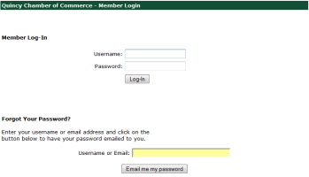  - If you lose your password simply go to this page and enter your email address that is shown on the membership directory in most cases. In a few seconds the system will send you what you need to login. | □
Primary Photo: | It’s like the interview for a new job… first 30 seconds the interviewer typically knows if they will hire you or not. When a person gets the result from the search engine the first thing they will see in many cases is this photo. Be sure it tells a story about your business or maybe even a photo of your staff.  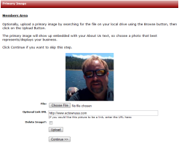  - A standard photo will work well in most cases and you may change this image at any time in the future. | □
About Us: | It is very important to add as much information about your company in the box as it helps the search engine determine if you provide the services the visitor is looking for.  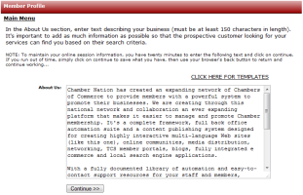  - This area is one of many that will help the search engine identify your business. Place as much information as possible in this area. You may cut and paste information into this box. | □
Business Hours: | The search result will deliver people to your online presentation. This presentation includes your business contact information and hours of operation. Mobile phone users will also see a “Business Hours” link to see what time your business is open to serve them.  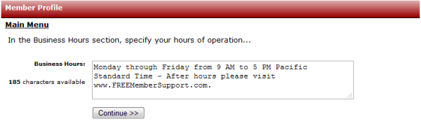  - This information will be displayed through the membership directory, search results page and through the mobile phone website we will be generating from this information for you. | □
Service Bullets: | It is very important to add as much information about your company in the boxes as it helps the search engine determine if you provide the products or services the visitor is looking for.  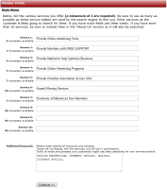  - A clue is derived from an example of a cleaning service company where they may want to offer services to both home owners and office complex landlords. So you would want to have the words somewhere in this area: residential, home, cleaning, office, business, carpets, ceilings, floors, waxing, windows, etc. | □
Fundraisers You Support: | This allows you to share with the public online about the fundraisers within the community that you support. It’s a great PR opportunity.  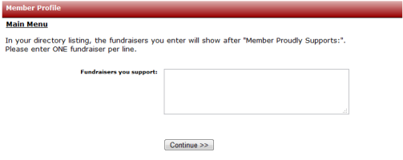  - When people find your business wouldn’t be nice to let them know that you support the community? Maybe you could add something like: High School Sports Programs, Citizens for Caring, Boys and Girls Clubs of America, Make-a-Wish Foundation, Lions Club, March of Dimes, etc. | □
Mobile Phone Site Domain: | Mobile phone usage is growing much faster than computer search services. For this reason the Chamber Search Engine promotes your business through a separate website designed for mobile phone visitors. You will be asked to choose a domain for this site too.  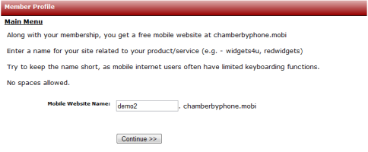  - If you own a pizza parlor in Austin Texas then a perfect name might be “AustinPizza”, or if you’re a Lawyer maybe “AustinLegal” would work best for you. | □
Create Defining Statement: | People will say “I don’t want to see your website I just want to get to the information I am looking for.” The defining statement is the first step in helping you create the presentation needed to convey the information people are looking for.  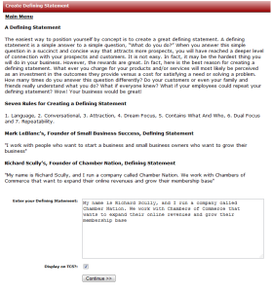  - A great defining statement for example is Mark LeBlanc’s:  "I work with people who want to start a business and small business owners who want to grow their business" | □
Create Your Keywords: | Within the narrative about what you provide as a business and organization might be valuable for people to read, but they typically use a search engine to look for specific words or phrases. Use this module to create a huge list of words that will help people find you based on exactly what they are looking for.  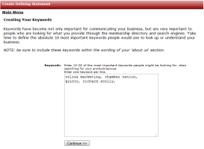  - One very important concept that should always be followed is to put your city name before the product or services you offer at least once. We’ll use the analogy of a provider of pool and spa services: Walnut Creek Spas, Contra Costa County Spas, Walnut Creek Spa Repair, Hot Tub Maintenance, Hot Tub Supplies, Finish Cleaner, Covers, Pumps, Thermostats, Coleman, etc. | □
Define Your Target Market: | People using the search engine are looking for a specific solution. By adding information about your target market people are able to easily find you based on the industry they are in.  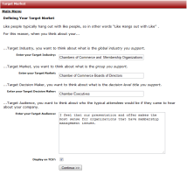  - If you are an auto repair shop that specializes in FLEET SERVICES then this will help power users looking for a repair company for their fleet of vehicles to find you. If you also provide services to the general consumer you would state this too. | □
Create Your Mission Statement: | Why should I do business with you? The mission statement helps you quickly and concisely convey to your viewers why they should trust you to deliver what they are looking for.  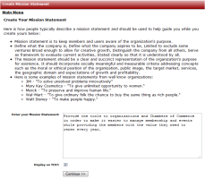  - Here is Walt Disney’s - "To make people happy." | □
Download Small Business Success Book: | Mark LeBlanc is the author of a book called “Growing Your Business” that’s designed to tie into the Chamber Search Engine technology. Download this book at no cost from within the Chamber system.    - Chamber Nation in association with Mark LeBlanc, the founder of Small Business Success and recent president of the National Speakers Association (NSA), has developed a PROVEN strategy to grow your business. Principals found in Mark's books and seminar series called the Achievers Circle have been used to create an inter-active coach. This unique program is only available through Chambers using the Chamber Nation system. | □
Edit Site: | This link will allow you to go through the initial setup of your Chamber Search Engine program. It’s a great way to be sure that your site is up-to-date and easily make changes.  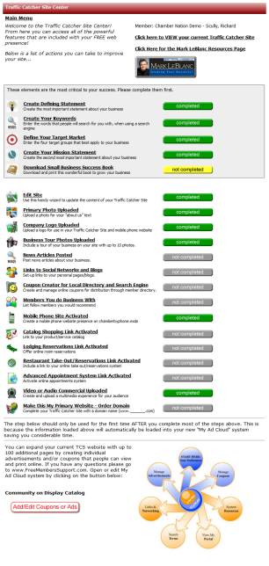  - We believe that once you login and see how simple the process is to clearly communicate your business properly, there is no doubt you will find the Chamber Search Engine program exceptionally useful for local marketing and many (if not all) of your online advertising needs.  - Turn the yellow or grey buttons GREEN and your done. Don’t take shortcuts if you want to grow your business! | □
Company Logo: | Upload your logo and if you don’t have a logo that can be used for your online advertising contact us at www.FreeMembersSupport.com and we’ll create one for you at NO charge.  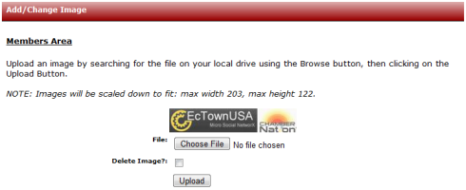  - This single logo image is used in a number of locations including your mobile phone website. Please don’t skip this step. If you don’t have a logo just call us and we’ll be happy to create one for you. | □
Business Tour Photos: | Along with your primary photo mentioned above, a photo tour / presentation is created with up to 10 images. Photos of your business, staff or even customers waving will speak volumes about you. It’s simple to do and provides so much goodwill that it’s something you really should do.  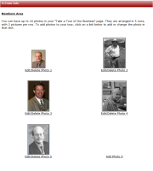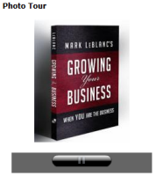  - If you are using a search engine to find a business, like a restaurant for instance, don’t you appreciate it when you find a really nice tour that gives you an idea of what that restaurant is going to be like? | □
News Articles: | Remember that this site will be accessed many times and once people find you through the Chamber Search Engine don’t disappoint them. Add news stories when you expand or add new product or services lines, get references from customers and more.  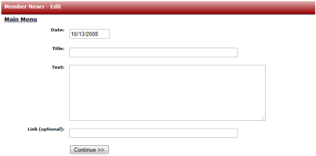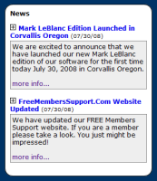  - News stories help you keep your website alive and current without needing to change your core content. Use the news module to keep visitors always up to date on what’s going on at your business. | □
Links to Social Networks: | The Chamber provides members with an exceptional way to promote your business. Now as people find you through the search engine and via the Chamber member directory, you can easily suggest that they ALSO view all of your other locations on the web. One site with a lot of valuable information.  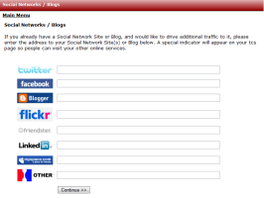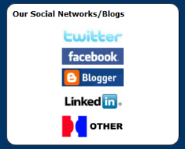  - Once you properly setup your program you will soon notice an increase in online activity. Many businesses are learning that they can dramatically expand their advertising through Social Networks, Blogs and Forums. By using the Chamber Search Engine system as a primary destination for your business, it will make it easy for visitors to visit all of your online presentations and resources. | □
Coupon Creator / Special Offers: | When the economy is tough people depend on many things to keep their costs down. Coupons are one of many ways businesses promote their business and the Chamber makes this easy for you to do. Do not confuse this service with the Community on Display or My Ad Cloud program as the coupon creator is designed to work directly with the Chamber Search Engine program.  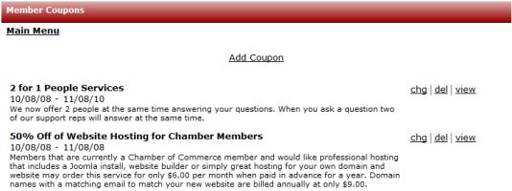  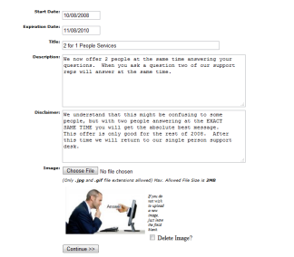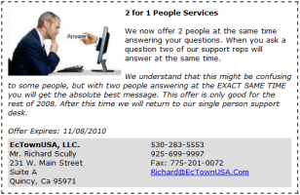  Print | Forward  - Once your special offers are created they will be highly promoted by the Chamber of Commerce and online through the website. Visitors can print the offer and even forward it to others they think might want to take advantage of it.  - These special offers are also posted through your mobile phone making them ideal for mobile distribution and through text messaging marketing. You can learn more about this by visiting www.ChamberTexting.com and www.MemberTexting.com (Coming late 2008). | □
Members You Do Business With: | Search results will deliver people to many businesses within the community. If others already work with your company, and they state this within this program then that becomes a 3rd party reference shown on the directory and your search engine website. This helps promote your business so be sure to promote others that you do business with you by using this service. A 3rd party reference is always the most powerful advertising you can ask for.  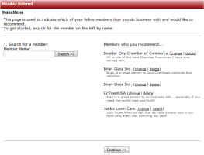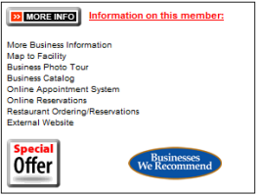  - What better promotion is there than having other business owners (Chamber Members) tell the world they do business with your company? You can start the ball rolling by using this very easy to use system to select the businesses from a list you do business with. Maybe they will do the same for you? Call them! | □
Mobile Phone Site: | The mobile phone site is generated and updated automatically whenever you make changes to your Chamber Search Engine program. Your Chamber promotes a mobile version of their main website that includes you and becomes a wonderful local resource and business directory tool on any Internet cell phone.  http://demo.chamberbyphone.mobi  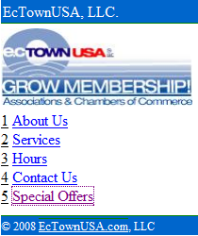 | □
Catalog Shopping Link: | If you choose to use the “My Ad Cloud” services (sometimes also included in your membership) this link will be automatically activated for you. If you are not using the “My Ad Cloud” service, but already have an online store or eBay account you can enter the link here and people viewing your search result will notice that you have an online store.  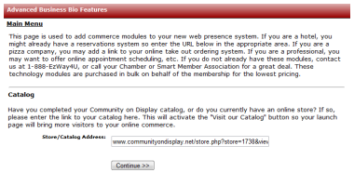 | □
Lodging Reservations Link: | If you are using the “My Ad Cloud” services you can setup a free reservation request system, but if you already have this available somewhere else online then you will want to place the link to that service here. It will also place an indicator on the Chamber member directory that you offer online reservations which gives you a competitive advantage.  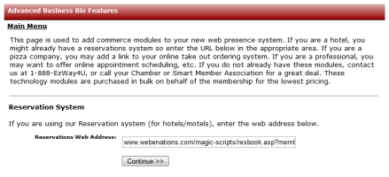 | □
Restaurant / Reservations Link: | If you already have this available online, place the link in this module to create an indicator on the membership directory with a link for this action. This service will deliver more traffic.  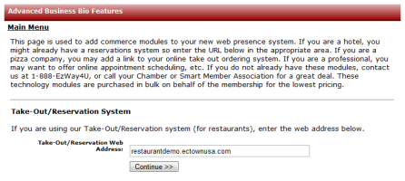 | □
Video or Audio Commercial Uploaded: | Video is the fastest growth area for advertising your business. It is this reason that we’ve incorporated tools within the program so you can easily create advertising videos at no charge. Once you create or upload your video, you can use the “Embedded” code to activate your commercial on the Chamber member directory, website and throughout the Internet.  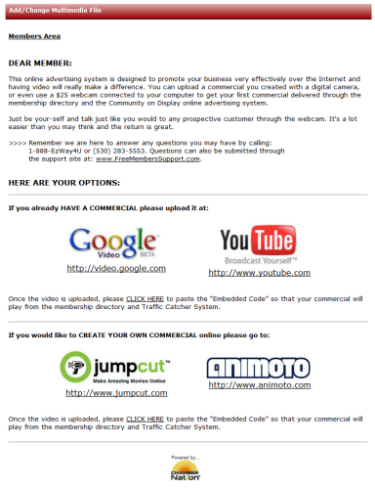   | □
Make this My Primary Website – Order Domain: | Most Chambers provide their members without websites with a custom website address at no charge. It even comes with a matching email service.  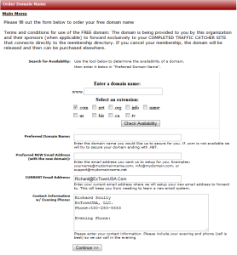  - If you don’t already have a website then this is a great service for you. Simply search for the domain name you would like and once you see that its available click the button to order and that’s it. The people at Free Members Support will provision the domain name and matching email address and then contact you.  - You will now have a full featured website already attached and optimized for the Chamber Search Engine. | □
My Ad Cloud Service | You can expand your current Chamber Search Engine (TCS) website with up to 100 additional pages by creating individual advertisements and/or coupons that people can view and print online. If you have any questions please go to www.FreeMembersSupport.com. This is a separate program often used for Shop Local programs. Please use the coupon generator above, unless you also want to present coupons in the shop local program. Ask your Chamber what might work best for you.  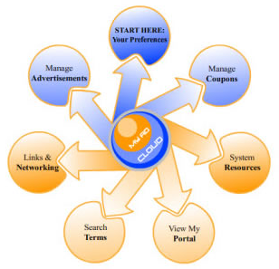  - My Ad Cloud is a powerful program that’s suggested for members who have fully optimized their Chamber Search Engine program and are looking to really expand their outreach through other search services. If you think you’re ready to go further please be sure all the steps above are done completely then feel free to expand the program with this program. | □
Support options
(we want you to succeed and get the most from your membership)
Phone Support | Free Members Support is part of the company that the Chamber of Commerce has hired to provide its members with robust online services. Although the service is FREE to members, the Chamber actually pays to provide you with this benefit and would hope that members take full advantage of it.  Their phone number is: 1-888-EzWay4U or (530) 283-5553  Phones are open from 9am to 5pm M-F – Pacific Standard Time | □
Email Support | You can contact the FREE Members Support group by emailing: Support@FreeMembersSupport.Com | □
Online Support | Learn more about the program, watch a video and even submit a help ticket online after hours by going to:  www.FreeMembersSupport.com | □

