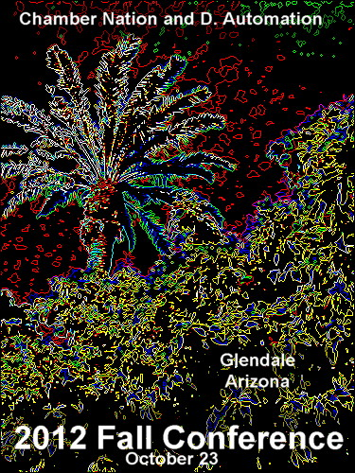
Time to Learn and Share
The 2012 Fall conference will be held in Glendale Arizona on Tuesday October 23rd. This will be a fantastic time for executives and administrators to learn how to get the most out of your programs. This will also be a great time to meet some of our staff and share your experiences with other executives. There will be time for one on one consultations and group sessions covering a wide variety of topics. We are looking forward to seeing you at the 2012 Fall Conference.
Monday October 22 7:30 PM Reception mixer
Tuesday October 23 | LABS FOR STAFF
8:30 AM  Welcome (Introductions) | During the conference staff will be available to discuss and train on individual requests. We will have a signup sheet for these labs. This will be a time for more in depth learning that would be great for admins and office staff. Topics will include newsletters, calendar, event registration, broadcast messages, billing, and general administrative questions. These labs will run concurrently with the regular sessions and will have the same start times. This will be a great time for admins to ask specific questions about areas in the program that affect them.  You will also be able to schedule time with our web designer and graphic artist..
9:00 -9:50
Custom Reports and More
Luke Tande will be presenting this informative session. Learn how to create custom reports and how to share those reports with members. Explore the media and file center to learn how to manage files and use the links to get your documents out to the public and members. See some of the “new” modules like the proposal submission system and the new learning center. Using the member business network will also be included in this session.
10:00-10:50  Advertising | General Administrative with Luke  Web solutions with Rocco  Communications with Richard
Sam Azzam will lead this session. Learn how to create effective banner advertising. One of our Graphic Designers will be available to discuss how to create effective art work. You will see examples of advertising that is being done at other chambers. Session will include time for best practices and sharing of ideas.
11:00-12:00  Getting the most out of your Website | Billing with Sam  General Administrative with Luke  Graphic Arts with Juliet
Rocco Condello will lead this session. Rocco is a web designer and will talk about how to make a beautiful web site that will grab attention and deliver results. Explore some of the new techniques for making your web site look even better.
12:00-1:00  Lunch | Lunch will be provided.  This will be a good time to network with other executives
1:00-1:50  Guest speaker | To be announced
2:00-2:50  Mobile Apps and Non Dues Revenue | Billing with Sam  General Administrative with Luke  Web solutions with Rocco  Graphic Arts with Juliet
Richard Scully will talk about the fast moving mobile app world. Learn why its important for your chamber to have a mobile presence. Learn how mobile apps can be a revenue generating program for the chamber. Session will include time for best practices and sharing of ideas.
3:00-3:50  It’s time to get your members Involved | General Administrative with Luke  Web solutions with Rocco  Graphic Arts with Juliet  Communications with Richard
Sam Azzam will take a look at the tools available for members including coupons and the buy local program. This session will include marketing tools available to your members and tips on how to get them using them. Session will include time for best practices and sharing of ideas.
4:00-5:00  Keeping your Chamber competitive | Billing with Sam  General Administrative with Luke  Web solutions with Rocco  Graphic Arts with Juliet
Richard Scully will be leading a discussion on the importance of having all members optimized. Also learn why it’s critical that your members are online. Session will include time for best practices and sharing of ideas.
Wednesday October 24^{th 9am to 3pm}
The Chamber Nation staff will be staying in the Phoenix area on Wednesday to do additional training. You can sign up for this extended session on Tuesday at the main conference. This will be a great time for any additional training you would like for executives or staff. We want you to receive as much training as you need.
Registration is only $99.00 for those who sign up before August 15th. Lunch is included

